Main Agenda- To show the bank account with filter and send PDF

To achieve this we need to create our own database with bank details

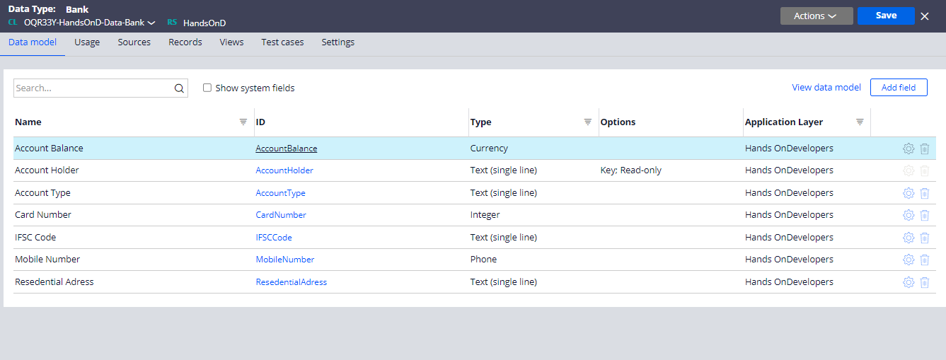

And after that we would crate the records

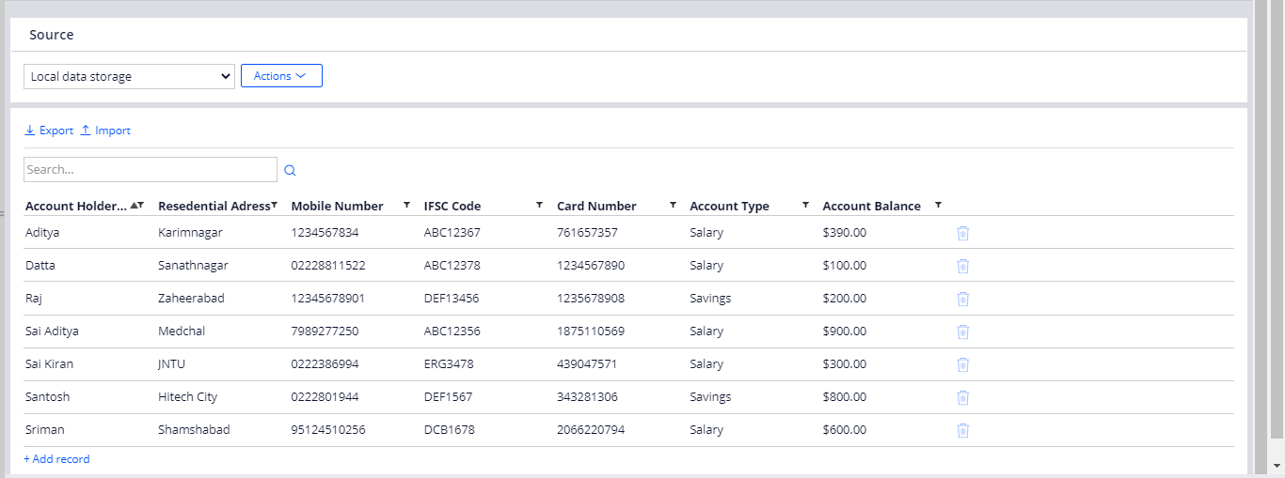

And then we can use the report in the same data class to fetch the records and display as per single user as parameter

And in the section we can display it and then create a table to map our properties

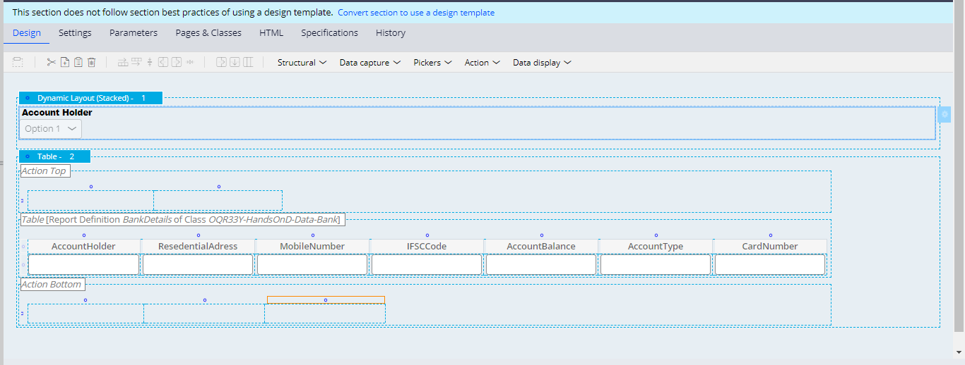

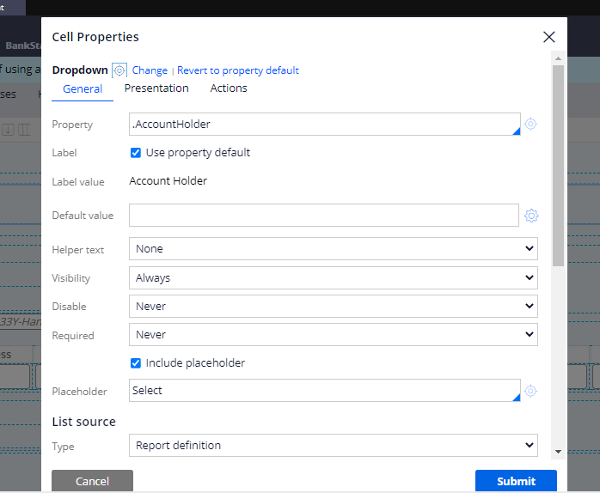

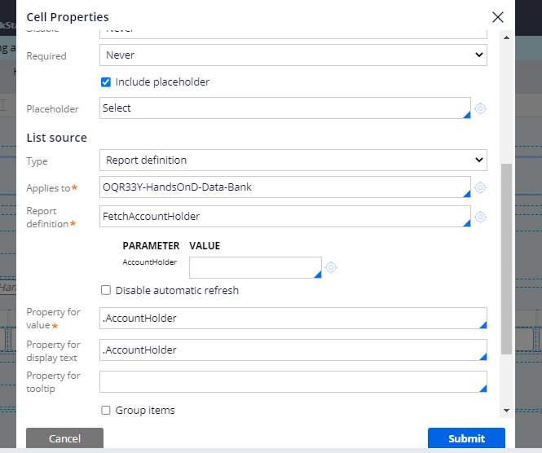

And then go for the dropdown and table creations

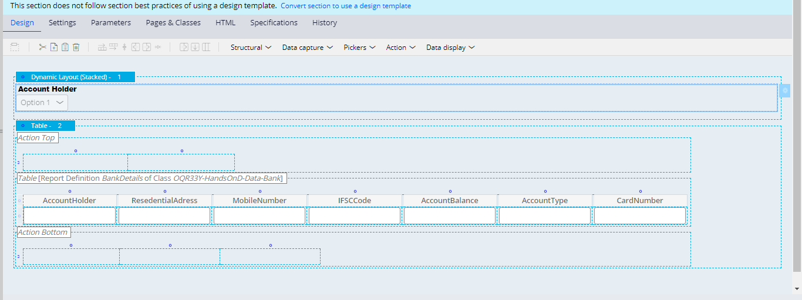

And then we would give the table the source having all the data

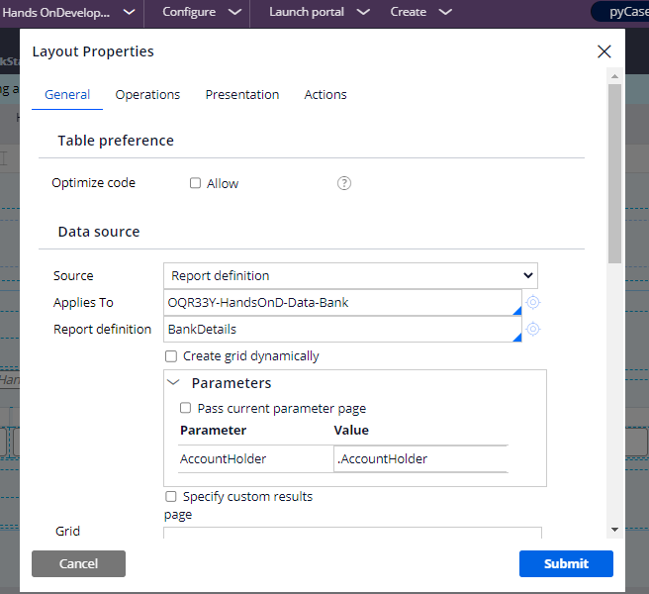

And then we can give the source and give our properties and show the details

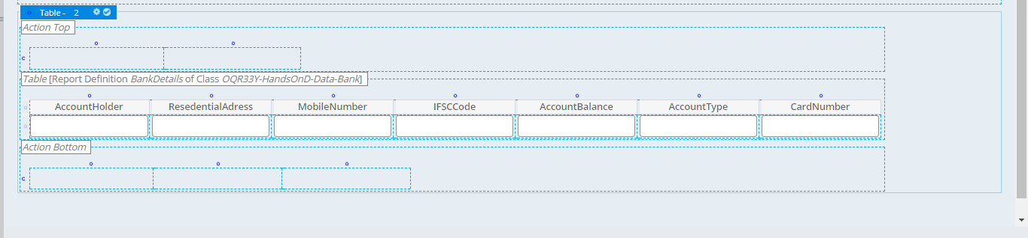

Now for sending the PDF we need to configure an activity to generate the report and convert that report as an PDF and send it to the user.

In the first step we need the report to be generated and then we need to pass the report class and report name

And in the second step

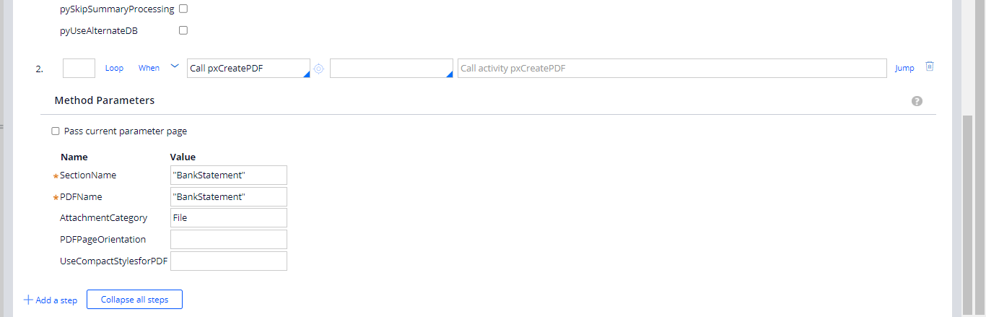

And give the section where statement is shown and then we can do the category name as File and then pass this in the post processing of the flow action to trigger the email and use the automation shape or we can use sendsimplemail activity by calling here also I am sing the create shape and in there using the category name as File and call the activity in the post processing

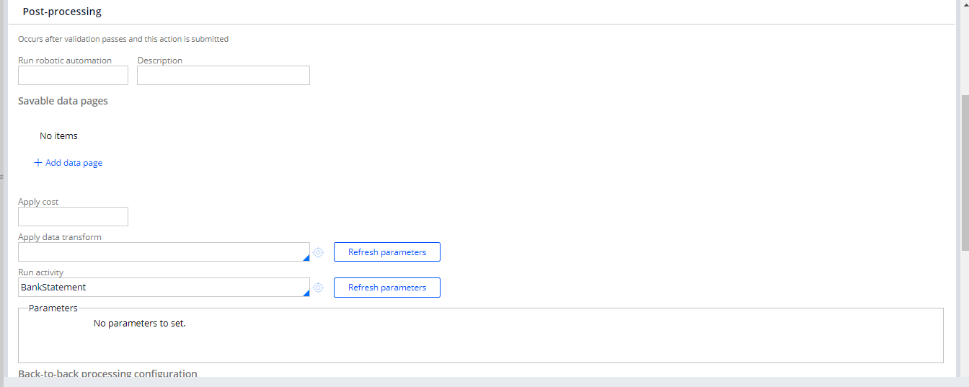

And then we need to run and check

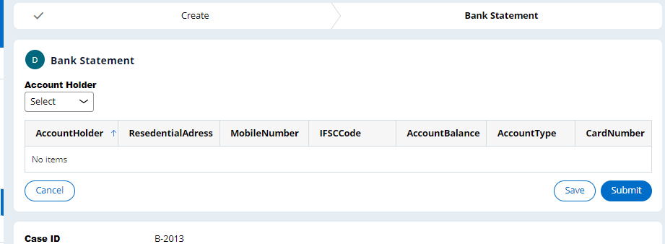

Blank Pdf

